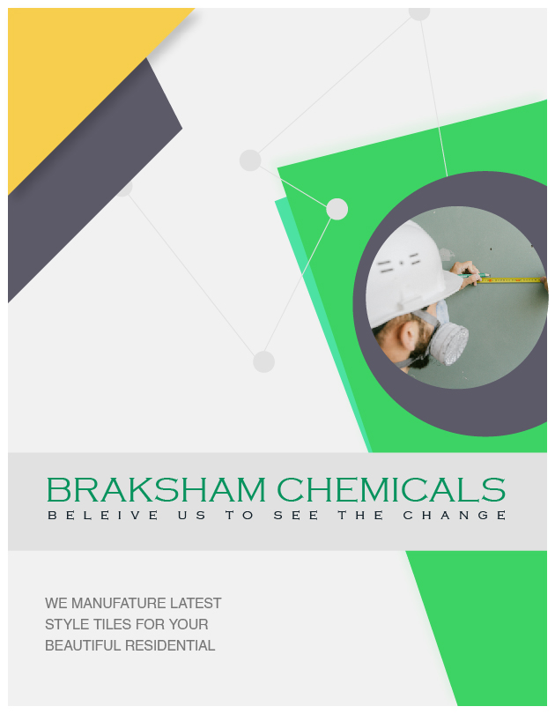

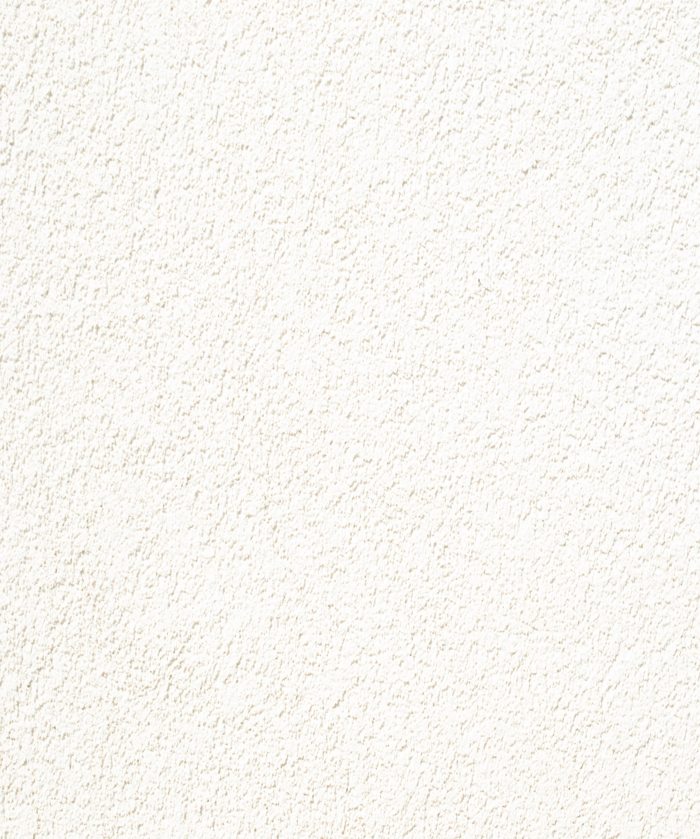

Enter the beautiful world of Premium Tiles

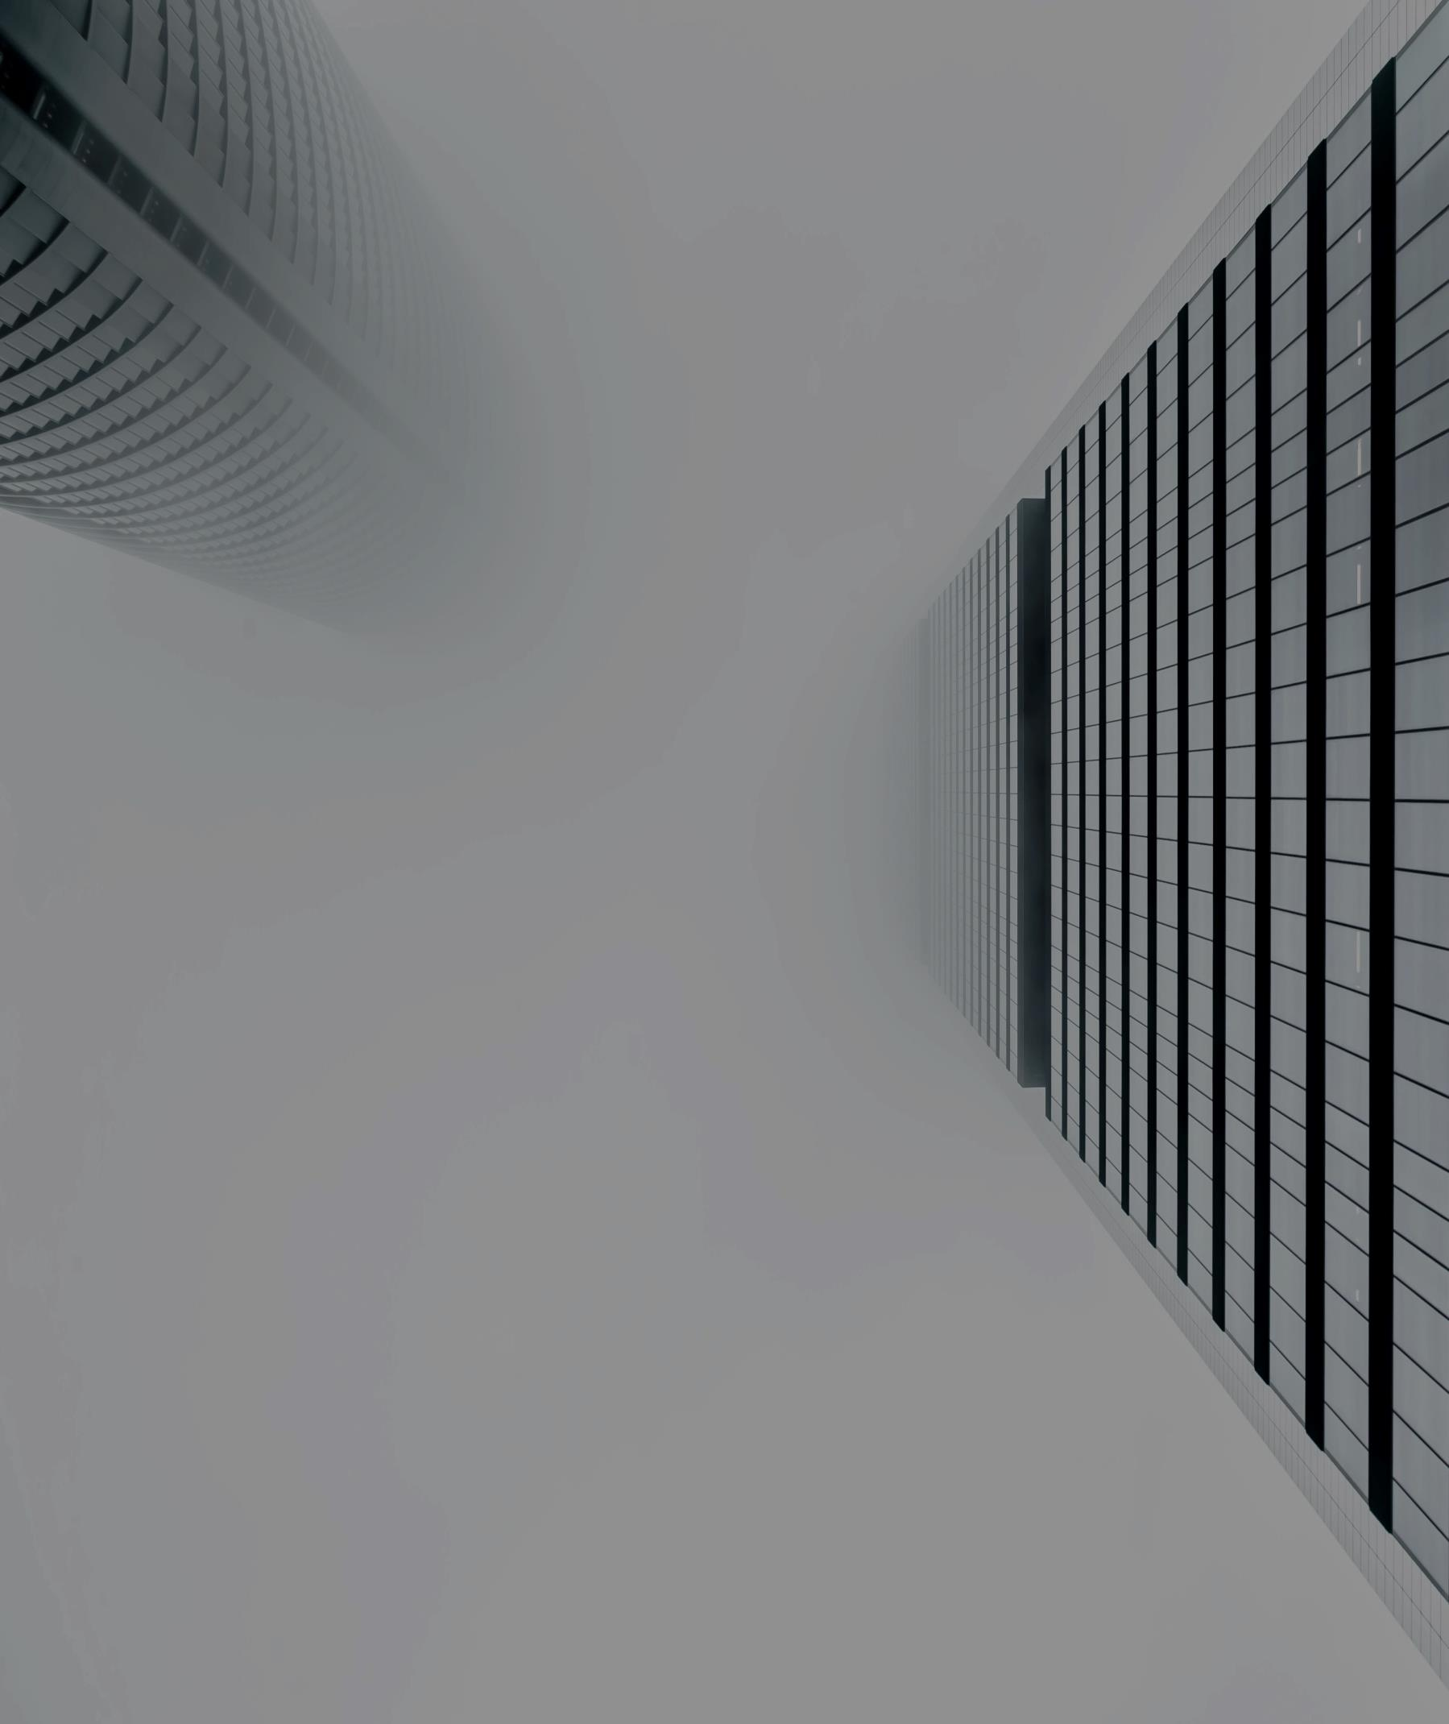

Comfy White Effect

Deep Carving Effect

R11, R9 Effect

High Gross Effect

Rockers Effect

Carving Effect

**Our Designs**